 **Remote Teams Fun Kit**

***“Teamwork is the ability to WORK TOGETHER toward a common vision. The ability to direct individual accomplishments toward organizational objectives. It is the fuel that allows common people to attain uncommon results.”***– Andrew Carnegie

# Half (51%) of remote workers report that they feel lonely working from home. This leads to less team unity and shared purpose and drives employees to less productive distractions such as chatting with friends and social media. To overcome this, leaders have found that adding social elements to meetings such as those in this Remote Teams Fun Kit increases cultural alignment to goals, employee engagement, and productivity.

# **“TWO TRUTHS AND A LIE”**

A simple, but a good one and very easy to do remote.

For those who aren’t familiar with the activity, it works like this: Each person takes turns to say **3 things about themselves — two of those things are *true* and one is a *lie*.** The group guesses which of the 3 is a lie — it’s good fun!

**Quick Ice Breakers**

# **EMOJI CHECK-IN**

A simple round table team check-in but this time instead of a one-word or something, you pic up to 4 emojis that best describe how you are feeling at that moment.

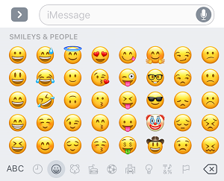

# **IF YOU COULD BE ANYWHERE IN THE WORLD RIGHT NOW…?**

As the title suggests, this activity is simply asking the question — “**if you could be anywhere in the world right now, where would you be?**”

* Create a list of categories to pick from each time
  + Examples: famous parks, hip cities, amusement parks, tropical islands, etc.
* Create a shared file folder and ask participants to download their photo to for everyone to see.
* Alternatively, you could have everyone upload the image as their webcam background screen – surprise!

# **CELL PHONE SCAVENGER HUNT**

# Assign points for even more fun!

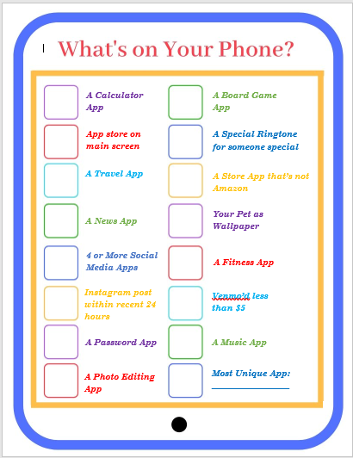

# **WHOSE PHOTO IS IT**

* Create a list of categories to pick from each time
  + Examples: in your work area, in your kitchen, hung on your wall, in your bathroom, outside, favorite place to sit, etc.
* Create a shared file for the team to insert their image into
* Either play by asking others to guess where you are, or simply discuss why you chose that picture.
* You can make this a regular icebreaker before your weekly meetings by picking a new topic each week.

# **PICTURE OR EMOJI CHARADES 🎞️**

GUESS THE MOVIE



Like Charades but with a remote twist where you can only use emoji’s for the movie/song/tv show title. For ideas, you can search for the “Emoji Charades” app in your app store and, we also found free printable versions at [mypartygames.com](https://www.mypartygames.com/free-printable-halloween-emoji-pictionary-game-with-answer-key/)

**TEAM BUILDING**

**PERSONALIZED WORD CLOUDS – Activity & Souvenir!!**

* + Team members submit one word each to describe each member on the team anonymously
  + Using a free wordcloud generator, create personalized wordclouds for each member on the team using the descriptors provided by teammates ([click](https://monkeylearn.com/blog/word-cloud-generator/) [here for some options](https://monkeylearn.com/blog/word-cloud-generator/))
  + During a meeting, we present teammates with individualzied word clouds with their name in center and characteristics surrounding, and go around saying who chose what word and why… **honoring our teammates for who they are and celebrating their individuality**

Team Building

**WORD SCAVENGER HUNT DURING ONLINE PRESENTATIONS**

This ensures the team is focused and spices things up!

* 1. Provide your team with a list of things to look for throughout the presentation (ie, pictures, symbols, words)
  2. At the end of the presentation, the teammember that has found the most items/treaures wins!
     + Items/treasures can be set up in a way to be thematic and tell a story:
       - Example: Company missions, innitiatives, values, goals, or even just random words, images symbols
       - Alternatively, you can pick a “word of the day” and use that word throughout the day. Team members will have to make sure they paying attention!



**TYPING SPEED TEST GROUP GAME:**

* + Free online team building activity where you can use MS Teams, ZOOM or other to gather your team… and everyone starts taking a typing test online at the same time
  + Whoever is the fastest and most accurate, wins!
  + You can grab yourself some free tests here ☺ <https://www.typingtest.com/>
  + One thing of note: ensure whole team is taking the same test!

**VIRTUAL FIREPSIDE CHAT – GETTING TO KNOW YOU BETTER:**

* + Share power point presentation with fire theme [Click for file](https://www.appleone.com/Employers/SCALE/Documents/Virtual-Fireside-Chat.pdf)
  + Have little smores kits delivered to team
  + Tell stories of success and challenges and have inspiring team bonding conversations

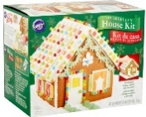

**THEMED VIRTUAL PARTY:**

* + Teams come dressed up, kits or lunch can be shipped out
  + Enjoy your teammates’ company while celebrating the holidays!
  + Play themed music, games or activities such as a **Cookie or Ginger Bread House Decorating party:** 
    - Or you can also use a virtual team building game service (examples can be found in the link below – can be more expensive)

<https://groups.coursehorse.com/event/gingerbread-house-holiday-party--materials-included>

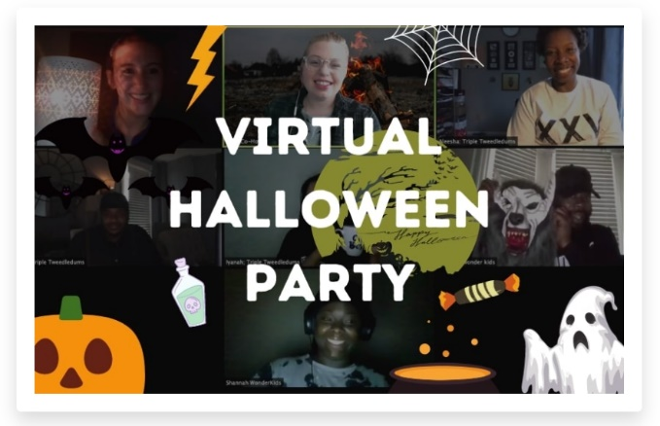

**PERSONALITY ASSESSMENTS:**

* + A fun way for leaders to get to know teammates, what drives them, their likes, dislikes, personalities, etc.
  + Helps teams to get a different perspective on why we are the way we are, to help teams work better together.
  + [Here’s a look at a few](https://www.topresume.com/career-advice/how-to-pass-the-pre-employment-personality-test)
  + [Here’s a look at Clifton Strengths](https://www.gallup.com/cliftonstrengths/en/252137/home.aspx) Finder

**CREATE FUN AND INTERACTIVE POWER POINT GAMES! FOR FREE!**

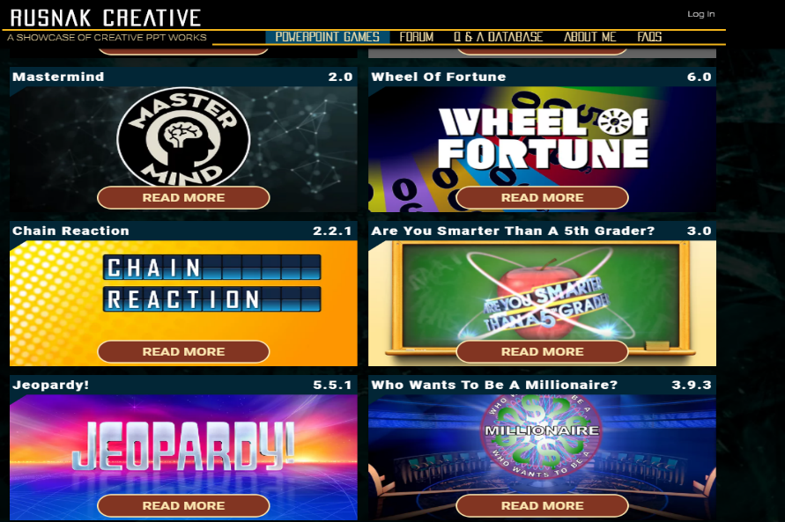

* + **Your beloved classics are now available for download on PC and MAC and fully customizable**

[Rusnak Creative Customizable Power Point Games](https://www.rusnakcreative.com/)

FUN!

**Whatta Game!**

**Happy Monday!**

**TGIF!**

**Did you catch that on TV?**

**PIN THE MAP:**

* + Create an interactive map of the world

[Here are some options for you to be able to do that](https://mapme.com/blog/6-free-tools-for-creating-your-own-maps/)

* + Go around the team asking where people were born, where they grew up and how they came to be where they are right now
  + Mark the map with the team’s information
  + Celebrate each other’s similarities and differences!

**together… we win!**

**REGULAR FRIDAY HAPPY HOURS OR MONDAY COFFEE BREAKS:**

* + Schedule recurring meetings that are more social to replace chat around the water cooler.
  + Ask open ended questions to help get the conversation going such as what are you most looking forward to doing this weekend?
  + If your team needs even more structure consider book clubs or discussions of movies/tv shows that the team selects and agrees to watch and then later discuss.